**1) Display the female users who are between the age group 18 and 25.**

SELECT user_id,fname||' '||Lname as Name,trunc((SYSDATE - BDATE)/365.25) as Age   
from fb_user where trunc((SYSDATE - BDATE)/365.25) >= 18   
and trunc((SYSDATE - BDATE)/365.25)<=25 and Gender='F' ;

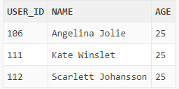

**2) Display the users who recently joined Facebook (after 2014)**

SELECT user_id,user_name

from fb_Account

where created_date>='01/01/2014';

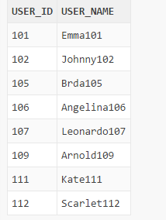

**3) Display the users and count of their friend list from the Database**

SELECT f.user_id,u.fname||' '||u.Lname as Name,  
Count(f.Friend_ID) as Num_of_Friends   
FROM user_friend f,fb_user u   
where u.user_id=f.user_id   
group by f.user_id,u.FNAME,u.lname;

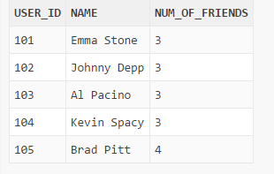

**4) Display the different kinds of statuses updated by the Facebook users so far**

SELECT unique(user_status) from user_status;

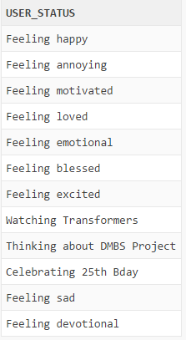

**5) Create a new event for the user id 101**

INSERT into Events Values (101,304,'Marathon','Be fit by participating in Marathon. Bring all your friends. We all will fun','30-Apr-2017');



**6) Display the events Emma Stone will be attending in the month of April 2017**

SELECT event_Id,evet_Name from Events where event_date>='01-Apr-2017' and event_date<='30-Apr-2017' and user_id=(select user_id from fb_user where fname='Emma' and lname='Stone');

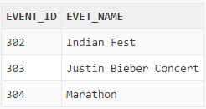

**7) Display all the Categories along with Category ID and Name which fall under Music category**

SELECT Category_Id,Name from Category_Likes where Category_Type='Music';

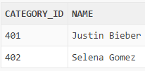

**8) Display the most visited place along with the city (more than 3 visits)**

SELECT Location, city from Check_ins group by Location, city having Count(Location) >3;

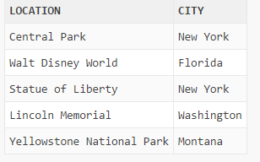

**9) Display the list of users who worked and currently working for Google**

SELECT fname||' '||lname as Name from fb_user where user_id in (SELECT user_id from workplace where organization='Google');

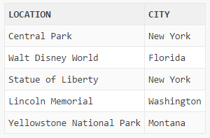

**10) Display the list of groups for which Johnny Depp is the Admin or owner of the group.**

SELECT group_id,group_name from groups where owner_id in (select user_id from fb_user where Fname='Johnny' and Lname='Depp');

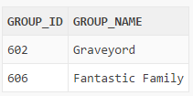

**11) Display the user id and user name of the users who are not even owner of a single group**

SELECT user_id,user_name from fb_user where user_id not in (select owner_id from groups);

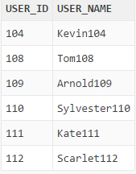

**12) Display the usernames of users who are going to University of Dayton and who are in the groups 'University of Dayton' and 'Arts and Science';**

SELECT user_name from fb_user where school_name like 'University of Dayton' and user_id in (select user_id from user_groups where group_name In ('University of Dayton','Arts and Science'));

